**WATER BILLING SYSTEM USER MANUAL**

**Dear user,**

First of all, I would like to thank you for using our system. You have acquired a reliable system which meets all your needs. If you have any trouble using our system or any error occurred while using our system you can contact us any time, we are always there for you to help.

**Purpose of the system,**

This is a system for calculate the water bill of a samurdhi recipients and non-samurdhi recipients.

**How to use our system,**

* Before calculating the water bill, you should enter two inputs to the system.
* The first input is the account number.

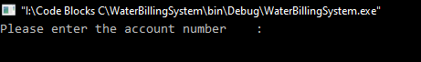

* If you enter a wrong account number, you will get an error message saying “***Please check the account number again!!!*”.**

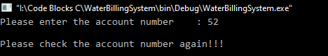

* If you enter the account number correctly, then the system will ask for the second input. At that point you should input the new meter reading.



* After you enter the new meter reading the water bill will print.

